 | Mandatory Disclosure | updated on: 10th March 2010
1. | AICTE File No. | 740-89-253(E)/RC/94
 | Date & Period of last approval | 2009 - 2010.
2. | Name of Institution | Ramrao Adik Institue of Technology
 | Address of Institution | Sector 7, Phase-I, Dr. D.Y. Patil Vidyanagar | 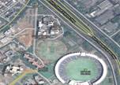
 | City & Pin Code | Nerul, Navi Mumbai-400706
 | State/UT | Maharashtra India
 | Longitude & Latitude | 19.03º N 73.01º E
 | Phone number with STD code | 022-27709505
 | FAX number with STD code | 022-27709573
 | Office hours at the Institution | 9.30a.m. to 5.30p.m.
 | Academic hours at the Institution | 9.30a.m. to 5.30p.m.
 | Email | rait@rait.ac.in
 | Website | www.rait.ac.in
 | Nearest Railway Station(dist in km) | Juinagar / Nerul (1 Km)
 | Nearest Airport(dist in km) | Chhatrapati Shivaji Internationa Airport, Mumbai (45 Kms)
3. | Type of Institution | Private-Self Financed
 | Category(1) of Institution | Non Minority
 | Category(2) of Institution | Co-Ed
4. | Name of the organization running the institution | Ramrao Adik Education Society
 | Type of the organization | Society/ Trust
 | Address of Organization | Opp. MIG Colony, Adarshnagar, Worli, Mumbai 025
 | Registered with | Charity Commissioner, Pune
 | Registration date | 05-11-1985
 | Website of the Organization | www.dypatil.edu
5. | Name of affiliating University | Mumbai University
 | Address | Fort Campus, Mumbai -400 032.
 | Website | www.mu.ac.in
 | Latest Affiliation period | Permanent Affiliation
6. | Name of Principal/ Director | Dr. Satish R. Devane
 | Exact Designation | Principal
 | Phone number with STD code | 022- 27709574
 | FAX number with STD code | 022-27709573
 | Email | satish@rait.ac.in principal@rait.ac.in
 | Highest Degree | Ph.D.(IITB)
 | Field of Specialization | Information Technology
7. | Governing Board Members
  Name | Educational Qualification | Credential
  Mr. Vijay D. Patil | MBA | President
  Dr. Ajinkya D. Patil | MBA | Vice President
  Mrs. P. D. Patil |  | Member
  Dr. (Mrs) Nandita Palshetkar | M D Gynecologist | Member
  Dr. S. K. Mahajan |  | Member
  Dr. H. N. Jain |  | Member
  Mr. Dinesh J. Parekh |  | Member
  Dr. S. R. Devane | Ph D | Secretory
 | Frequency of meeting & date of last meeting | Twice in a year and as when required
8. | Academic Advisory Body
  Name | Designation | Representative
  Dr. Devane S. R. | Principal | (Convener Academic Council)
  Mr. Patil M.D. | (HOD Electronics Engg ) | Member
  Mrs. Ragha L.L. | (HOD Computer Engg) | Member
  Mr. Lengare M. J. | (HOD Instrumentation Engg.) | Member
  Mrs. Chatterjee M.A. | (HOD Information Tech) | Member
  Mr. Khade R. H. | (HOD Electronics & Tele) | Member
  Dr. Shete S. D. | (HOD Humanity Science) | Member
  Mr Kale O. R. | (UG Co-Ordinator) | Member
  Mr Vidhate A.V. | Training & Placement Co-ordinator | Member
  Mr Nakara A. N. | Student Affairs | Member
 | Frequency of meeting & date of last meeting | Once in a month and as when need arises
9. | Organizational Chart | 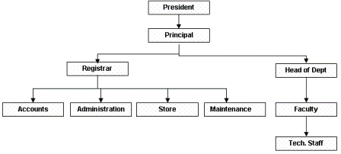
10. | Student feedback mechanism for faculty, staff and students | Student feedback is collected at the end of academic year.
11. | Grievance redressal mechanism for faculty, staff & students | A redressal committee of senior faculty members is there to look after the major grievances of the students, whereas day to day grievances are sorted out by class counselor. However, the redressal of grievances of faculty members is carried out by their respective HOD, Director and Principal. Staff members’ grievances are taken care their respective HOD.
12. | Name of Department* | Computer Engineering
a. | Course | Computer Engineering
 | Level | UG/ PG
 | 1st Year of approval by the Council | 1994
 |  | 2009-2010 | 2008-2009 | 2007-2008
 | Year wise Sanctioned Intake | 120 | 120 | 120
 | Year wise Actual Intake | 122 | 121 | 121
 | Cut-off marks -General Quota | 141 | 128 | 85
 | % Students passed with Distinction | - | 23 | 17
 | % Students passed with First Class | - | 48 | 41
 | Students Placed | 63 | 71 | 92
 | Average Pay package, Rs./Year | 3.25 lacs | 3.25 lacs | 3.25 lacs
 | Students opted for Higher Studies | - | 04 | 10

 | Accreditation Status of the course | Non Accredited
 | Doctoral Courses | No
 | Foreign Collaborations, if any | No
 | Professional Society Memberships | IEEE, CSI, ISA
 | Professional Activities | With Student Chapters
 | Consultancy Activities
 | Grants fetched | Computer & Information Technology – 25.0 lacs
 | Departmental Achievements | With Student Chapters
 | Distinguished Alumni
  Sr. No. | Name | Distinctive
  1. | Mr. Vijay D. Patil | President, Dr. D. Y. Patil Group
  2. | Mr. Pankaj Phatarphod | Vice President, ABN Amro Bank, USA
  3. | Mr. Manni Kantipudi | Director, Intel India
  4. | Mr. Abbey Kuruvilla | Ex Member, Indian Cricket Team
  5. | Mr. Shankar Mahadevan | Pop Singer & Music Director
  6. | Mr. Amit Behl | Performer in arts , TV actor
  7. | Mr. Aniket Bharambe | Asst. Genertal Manager, Mastek Mumbai
  8. | Mr. Sandeep Pendharka | Consultant, Language Processing Lab, Banglore
12. | Name of Department* | Electronics Engineering
b. | Course | Electronics Engineering
 | Level | UG/ PG
 | 1st Year of approval by the Council | 1994
 |  | 2009-2010 | 2008-2009 | 2007-2008
 | Year wise Sanctioned Intake | 120 | 120 | 120
 | Year wise Actual Intake | 121 | 122 | 122
 | Cut-off marks -General Quota | 142 | 122 | 83
 | % Students passed with Distinction | - | 27 | 12
 | Students Placed | 53 | 79 | 116
 | Average Pay Package,Rs./Year | 3.25 lacs | 3.25 lacs | 3.25 lacs
 | Students opted for Higher Studies | - | 14 | 25

 | Accreditation Status of the course | Non Accredited
 | Doctoral Courses | No
 | Foreign Collaborations, if any | NA
 | Professional Society Memberships | IEEE, CSI, ISA
 | Professional Activities | With Student Chapters
 | Consultancy Activities
 | Grants fetched
 | Departmental Achievements
 | Distinguished Alumni
  Sr. No. | Name | Distinctive
  1. | Mr. Vijay D. Patil | President, Dr. D. Y. Patil Group
  2. | Mr. Pankaj Phatarphod | Vice President, ABN Amro Bank, USA
  3. | Mr. Manni Kantipudi | Director, Intel India
  4. | Mr. Abbey Kuruvilla | Ex Member, Indian Cricket Team
  5. | Mr. Shankar Mahadevan | Pop Singer & Music Director
  6. | Mr. Amit Behl | Performer in arts , TV actor
  7. | Mr. Aniket Bharambe | Asst. Genertal Manager, Mastek Mumbai
  8. | Mr. Sandeep Pendharka | Consultant, Language Processing Lab, Banglore
12. | Name of Department* | Electronics & Telecommunications
c. | Course | Electronics & Telecommunications
 | Level | UG
 | 1st Year of approval by the Council | 1994
 |  | 2009-2010 | 2008-2009 | 2007-2008
 | Year wise Sanctioned Intake | 90 | 90 | 90
 | Year wise Actual Intake | 91 | 92 | 91
 | Cut-off marks -General Quota | 161 | 143 | 84
 | % Students passed with Distinction | - | 23 | 26
 | % Students passed with First Class | - | 58 | 44
 | Students Placed | 57 | 65 | 99*(few with dual offer)
 | Average Pay Package,Rs./Year | 3.25 lacs | 3.25 lacs | 3.25 lacs
 | Students opted for Higher Studies | - | 10 | 08

 | Accreditation Status of the course | Non Accredited
 | Doctoral Courses | No
 | Foreign Collaborations, if any | NA
 | Professional Society Memberships | IEEE, ISA, CSI
 | Professional Activities | With Student Chapter
 | Consultancy Activities
 | Grants fetched
 | Departmental Achievements
 | Distinguished Alumni
  Sr. No. | Name | Distinctive
  1. | Mr. Vijay D. Patil | President, Dr. D. Y. Patil Group
  2. | Mr. Pankaj Phatarphod | Vice President, ABN Amro Bank, USA
  3. | Mr. Manni Kantipudi | Director, Intel India
  4. | Mr. Abbey Kuruvilla | Ex Member, Indian Cricket Team
  5. | Mr. Shankar Mahadevan | Pop Singer & Music Director
  6. | Mr. Amit Behl | Performer in arts , TV actor
  7. | Mr. Aniket Bharambe | Asst. Genertal Manager, Mastek Mumbai
  8. | Mr. Sandeep Pendharka | Consultant, Language Processing Lab, Banglore
12. | Name of Department* | Instrumentation Engineering
d. | Course | Instrumentation Engineering
 | Level | UG
 | 1st Year of approval by the Council | 1994
 |  | 2009-2010 | 2008-2009 | 2007-2008
 | Year wise Sanctioned Intake | 60 | 60 | 60
 | Year wise Actual Intake | 61 | 61 | 61
 | Cut-off marks -General Quota | 140 | 115 | 53
 | % Students passed with Distinction | - | 7 | 14
 | % Students passed with First Class | - | 59 | 49
 | Students Placed | 7 | 40 | 30
 | Average Pay Package,Rs./Year | 3.25 lacs | 3.25 lacs | 3.25 lacs
 | Students opted for Higher Studies | - | 05 | 05

 | Accreditation Status of the course | Non Accredited
 | Doctoral Courses | No
 | Foreign Collaborations, if any | No
 | Professional Society Memberships | ISA, IEEE, CSI
 | Professional Activities | With Student Chapters
 | Consultancy Activities
 | Grants fetched
 | Departmental Achievements
 | Distinguished Alumni
  Sr. No. | Name | Distinctive
  1. | Mr. Vijay D. Patil | President, Dr. D. Y. Patil Group
  2. | Mr. Pankaj Phatarphod | Vice President, ABN Amro Bank, USA
  3. | Mr. Manni Kantipudi | Director, Intel India
  4. | Mr. Abbey Kuruvilla | Ex Member, Indian Cricket Team
  5. | Mr. Shankar Mahadevan | Pop Singer & Music Director
  6. | Mr. Amit Behl | Performer in arts , TV actor
  7. | Mr. Aniket Bharambe | Asst. Genertal Manager, Mastek Mumbai
  8. | Mr. Sandeep Pendharka | Consultant, Language Processing Lab, Banglore
12. | Name of Department* | Information Technology
e. | Course | Information Technology
 | Level | UG
 | 1st Year of approval by the Council | 1994
 |  | 2009-2010 | 2008-2009 | 2007-2008
 | Year wise Sanctioned Intake | 60 | 60 | 60
 | Year wise Actual Intake | 61 | 60 | 60
 | Cut-off marks -General Quota | 129 | 122 | 65
 | % Students passed with Distinction | - | 25 | 27
 | % Students passed with First Class | - | 50 | 41
 | Students Placed | 36 | 41 | 43
 | Average Pay Package,Rs./Year | 3.25 lacs | 3.25 lacs | 3.25 lacs
 | Students opted for Higher Studies | - | 02 | 05

 | Accreditation Status of the course | Non Accredited
 | Doctoral Courses | No
 | Foreign Collaborations, if any | NA
 | Professional Society Memberships | IEEE, CSI, ISA
 | Professional Activities | With Student Chapter
 | Consultancy Activities
 | Grants fetched | Computer & Information Technology – 25.0 lacs
 | Departmental Achievements
 | Distinguished Alumni
  Sr. No. | Name | Distinctive
  1. | Mr. Vijay D. Patil | President, Dr. D. Y. Patil Group
  2. | Mr. Pankaj Phatarphod | Vice President, ABN Amro Bank, USA
  3. | Mr. Manni Kantipudi | Director, Intel India
  4. | Mr. Abbey Kuruvilla | Ex Member, Indian Cricket Team
  5. | Mr. Shankar Mahadevan | Pop Singer & Music Director
  6. | Mr. Amit Behl | Performer in arts , TV actor
  7. | Mr. Aniket Bharambe | Asst. Genertal Manager, Mastek Mumbai
  8. | Mr. Sandeep Pendharka | Consultant, Language Processing Lab, Banglore
13. | Name of Teaching Staff* | Computer Department  Electronics & Telecommunication Department  Electronics Department  Engineering Science Department  Instrumentation Department  Information Technology Department
14. | Admission quota*
 | Entrance test/admission criteria | Admission process is governed by Director of Technical Education, Maharashtra through AIEEE and CET.
 |  | 2009-2010 | 2008-2009 | 2007-2008
 | Cut off / last candidate admitted | 47 (CET) | 59 (CET) | 49 (CET)
 | Fees in rupees | 54,000/- | 51,760/- | 48,000/-
 | Number of Fee Waivers offered | - | - | -

 | Admission Calender | Calendar for admission against management /vacant seats:  Last date for request for applications. : 03.07.09  Last date for submission of application. : 03.07.09  Dates for announcing final results. : 09.07.09  Release of admission list (main list and : 14.07.09 to  waiting list should be announced on the same day) : 16.07.09  Date for acceptance by the candidate (time given should in no case be less than 15 days) : 16.07.09  Last date for closing of admission. : 08.09.09  Starting of the Academic session. : 31.08.09  The waiting list should be activated only on the expiry of date of main list.
 | PIO quota | NA
15. | Infrastructural Information*
 | Classroom/Tutorial Room facilities | 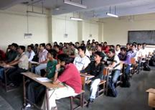  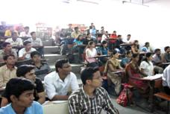
 | Laboratory details | 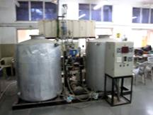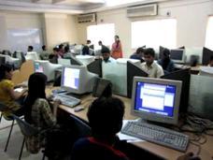
  Department | Laboratory Name | Lab / Major Equipments | Laboratory Investment (in Rs)
  Computer Engineering | Advance Network | Dell PC PIV, Printer, Access Point, switches | 11.57
  Computer Engineering | Basic Software | PC-Diskless, Printer, Switches | 9.92
  Computer Engineering | CS-Project Lab | HP PIV, Printer, Switches | 12.92
  Computer Engineering | CS-Research | Dell PC-PIV, Simulator, Matlab | 10.35
  Computer Engineering | CS-Server | IBM-xSeries Xeon Server, lan accessory | 11.69
  Computer Engineering | Computer Labs | -- | --
  Computer Engineering | Database Lab | Dell PC PIV, Printer, Access Point, switches | 12.33
  Computer Engineering | Design Lab | Dell PC PIV, Printer, Access Point, switches | 11.6
  Computer Engineering | Graphics Lab | IBM-PIV, Printer, Switches | 15.98
  Computer Engineering | Hardware & Mp | IBM PC PIV, Printer, Access Point, | 11.58
  Computer Engineering | Image Processing | IBM-PC PIV, Printer, Access Point, switches, Matlab | 14.16
  Computer Engineering | Int System Lab | PC PIV, Printer, Access Point, switches | 9.94
  Computer Engineering | Network Lab | Dell PC PIV, Printer, Access Point, switches | 13.12
  Electronics & Telecommunication Engineering | Advance Comm | Microwave Component, Fiber optics kit Communication Kits Signal Generator Spectrum Analyser | 20.03
  Electronics & Telecommunication Engineering | Basic Communication Lab | CRO, Powersupply & Function Generator Modulation Demodulation Kits, | 12.61
  Electronics & Telecommunication Engineering | Data Comm | Digital Communication Kit, PC Duel core, | 6.08
  Electronics & Telecommunication Engineering | Digital Comm | Digital Communication Kit, CRO,Function Generator powersupply | 9.63
  Electronics & Telecommunication Engineering | Digital Electronic | VLSI Trainer Kit, IC Trainer, CRO, Powersupply,Function Generator, MM | 6.83
  Electronics & Telecommunication Engineering | E-Workshop | Function Generator,CRO, Powersupply, MM | 6.03
  Electronics & Telecommunication Engineering | EDC | CRO, Powersupply,Function Generator, MM | 6.03
  Electronics & Telecommunication Engineering | MicroController Lab | Z-80,8085,8086,8088,8051 kits With Interfacing cards | 6.4
  Electronics & Telecommunication Engineering | TV, Video and Antenna | TV Trainer Kit, Pattern generator Digital Storage Osciloscope,Antenna trainer Kit | 7.41
  Electronics Engineering | Basic Electrical Lab | Basic Electrical Kit, AC DC Bridges,DC Motor, Ac Motor, DC generetor, Syncronos motor | 7.25
  Electronics Engineering | Communication Lab | Modulation Demodulation Kits,CRO, Powersupply & Function Generator | 19
  Electronics Engineering | Control Laboratory | Control System Kit, Power Electronic Kit, PC PIV | 11.75
  Electronics Engineering | DSP | PC PIV, Signal generator, Spectrom Analyser, Math Lab | 14.25
  Electronics Engineering | Digital Electronic & LIC | IC Trainer, CRO, VLSI Trainer Kit, Powersupply,Function Generator, MM, Xilinx, EdwinXp | 10.25
  Electronics Engineering | EC-Research | PC-PIV, Simulator, Matlab,Pspic, Candance | 8.12
  Electronics Engineering | Electronics Lab | CRO, Function Generator, Powersupply, PC, ORCAD | 20.26
  Electronics Engineering | MicroProcessor Lab | Z-80,8085,8086,8088,8051 kits With Interfacing cards, Logic Analyser, Pc pIV, ARM processor Kit | 8.76
  Electronics Engineering | Project Lab | CRO, Function Generator, Powersupply, PC,ORCAD | 17
  First year subjects | CAD | - | 14.61
  First year subjects | Chemistry | - | 6.23
  First year subjects | Language Lab | - | 1.86
  First year subjects | Physics | - | 5.32
  First year subjects | Workshop | - | 7.89
  Information Technology | ADMS & Data Mining | IBM PIV,PIII,Princter | 7.94
  Information Technology | IP & DSP Lab | IBM PIV,PIII,Printer, MatLab | 10.77
  Information Technology | IT-Project Lab | IBM PIV,PIII,PDA,Printer, Projector | 11.8
  Information Technology | IT-Server | Sun Fire Server, Switch, IBM x22 Xeon Server | 17.59
  Information Technology | Mobile Computing | IBM pIV,PDA,Printer | 14.04
  Information Technology | Multi Media Lab | IBM PIV,PIII,Printer, laptop, projector, LCD TV | 6.3
  Information Technology | Software Lab | SUN Rays, SUN Blades, Country Kit, US Unix | 19.32
  Instrumentation Engineering | Analytical Instumentation & Bio Medical | Analytical Instrumentation, DC Defabriaator,ECG Symulator, EMG, UV Spectro photo meter | 2.94
  Instrumentation Engineering | Control System Lab | CRO, CV Testing, PC, Mat Lab, P2I and I2P Converter | 6.43
  Instrumentation Engineering | IN-Project lab | 9 in one Test bench, DSO,CRO,Labview, MatLab | 8
  Instrumentation Engineering | Process Instrumentation | Heat exchanger setup, Pneumatic Setup,PLC,PC | 12.16
  Instrumentation Engineering | Transducer Lab | Transducer kits, CRO, Powersupply, Function Generator | 2.52
 | Computer Centre facilities | 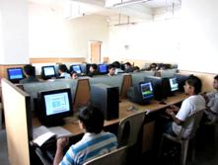  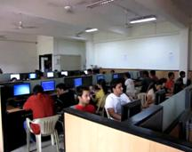
 | Library facilities | Number of Library books/Titles/Journals available (programme-wise)  List of online National/International Journals subscribed. INDEST - IEEE & Springer link e-journal subscription (more than 300 online journals) Viewing and downloading facility is available. E-Library facilities INDEST-IEEE and Springer link Online Journals are available  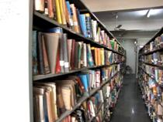 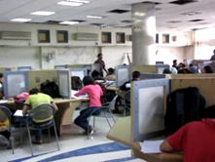
  Branch | No & Titles | Volume
  Computer Engg | 4122 | 12990
  Electronics Engg | 2821 | 9189
  Instrumentation Engg | 996 | 2426
  Information Tech | 1432 | 3640
  Electronics & Telecomm | 760 | 2569
  Total | 10131 | 30841
 | Auditorium/ Seminar Halls/ Amphi | 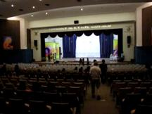  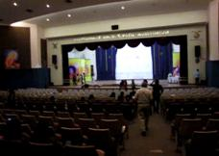
 | Cafeteria | 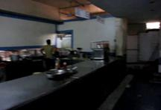  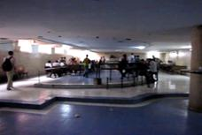
 | Indoor Sports facilities | 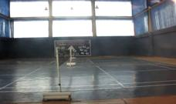  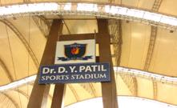
 | Outdoor Sports facilities | 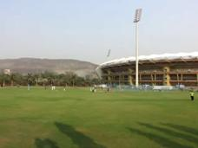  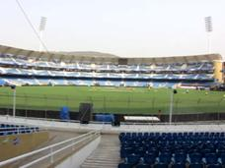
 | Gymnasium facilities | 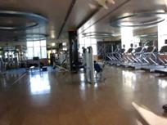  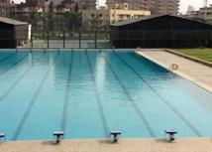
 | Facilities for disabled | NA
 | Any other facilities | 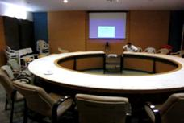  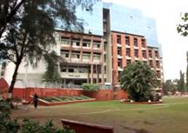
16. | Boys Hostel | No
 | Girls Hostel | Yes (10 rooms / 30 students)
 | Medical & other facilities at hostel | Available
17. | Academic Sessions
 | Examination system, Year/ Sem | Semester
 | Period of declaration of results | 45 Days
18. | Couseling/ Mentoring | Available
 | Career Counseling | Available
 | Medical Facilities | Available
 | Student Insurance | Yearly for all admitted students
19. | Students Activity Body | SUC, CSI, ISA, IEEE
 | Cultural activities | "Kalarag" – A students association’s annual state level cultural event
 | Sports activities | Available
 | Literary activities | Available
 | Magazine/ Newsletter | "The Wall" is annual magazine for student body, further students chapters are also having the annual magazine vize. "crux" for ISA, for "COZINE" CSI and "BRACKETS" for IEEE.
 | Technical activities/ TechFest | Along with CSI, IEEE, & ISA student chapters
 | Industrial Visits/ Tours | Every year once in vacation period for each department
 | Alumini Activities | From last 6 years association is active and organizing events.www.alumni.rait.ac.in
20. | Name of the Information Officer for RTI | Mr. Uday Shende
 | Designation | Director
 | Phone number with STD code | 022- 27709574
 | FAX number with STD code | 022-27709573
 | Email | director@rait.ac.in

